Ore ga Kanojo o Okasu Wake

Episode 01

Written by Mistress Valentine

Ore ga Kanojo o Okasu Wake, Episode 1, is a hentai based on the manga "Ore ga Kanojo o Okasu Wake" which was released in 2016 by Suzuki Mirano. Directed by Yokoyama Hiromi and released in 2018, Ore ga Kanojo o Okasu Wake Episode 1 runs at 15-17 minutes long. Censored genitals. English subtitles available.

Fetishes: Schoolgirl, Pussy Play, Vaginal sex, Rape, Incest, Creampie, Big boobs, Blowjob, Mind Break

**STORY**

Rinka, an ordinary high-schooler, runs away from home and settles to live with her attractive uncle (who doesn’t seem to have a first name) and much to his reluctance, makes herself right at home. A simple request for juice leads Uncle to find an old vial of super-duper-pussy-opening aphrodisiac spray that make women want dick more than oxygen. Not quite sure how he forgot he had such a magnificent item in his possession, but it doesn’t take long for him to use the spray on Rinka.

Why you ask?

It turns out that he is madly in love with Rinka’s mother, Uncle’s brother’s wife. But because he was too young at the time of their first meeting, Uncle couldn’t act upon his feelings. However, since Rinka looks so much like her mother, fucking daughter is kind of like fucking the mother, isn’t it? Uncle’s dick seems to think so.

Once the aphrodisiac kicks in, Uncle goes to town on Rinka with some over the sweater pussy playing and some breast squeezing for good measure. The first sex scene between them has mostly rapey vibes to it with Rinka all sexed up, but still in possession of her marbles so she resists and protests until Uncle finds something else to put inside her mouth.

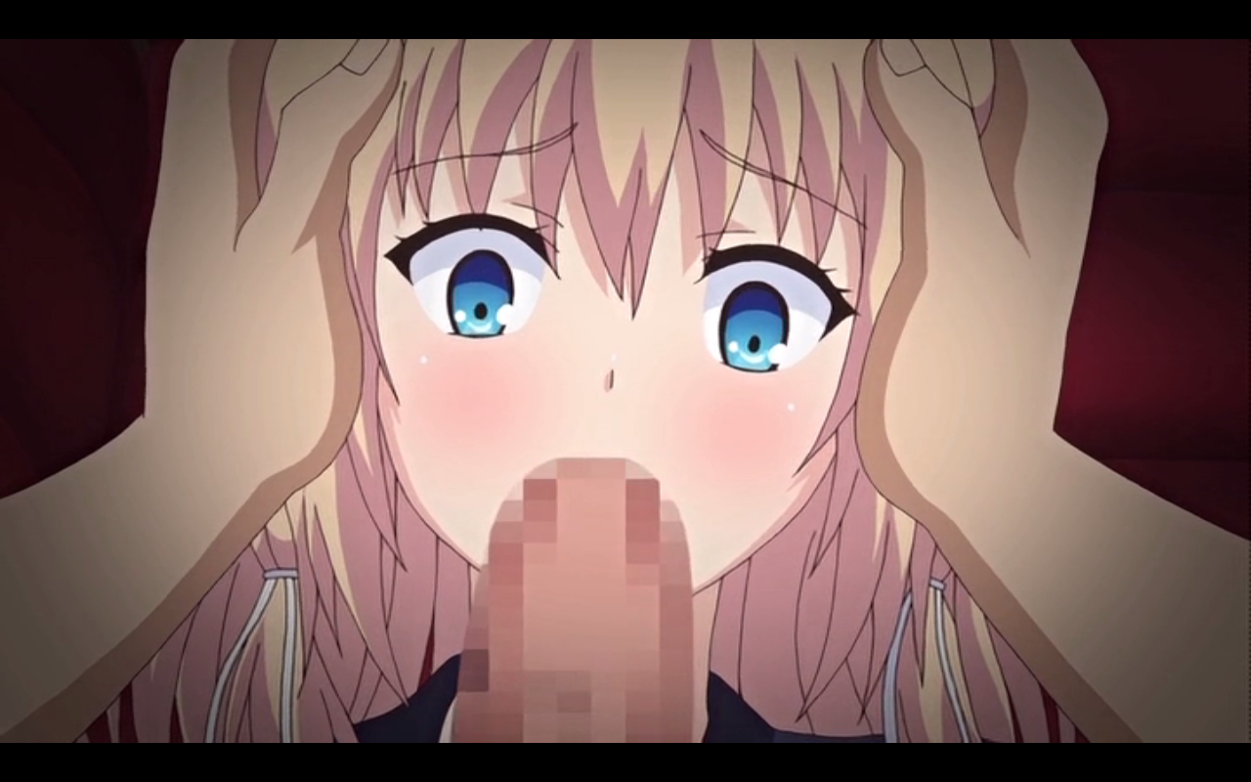

After he gives her good dose of vitamin-D, Rinka passes out, but the fun doesn’t stop there. She wakes up later to secret videos of her parents having sex playing and we learn that Rinka has a daddy fetish. After she gets herself off, Uncle reminds her he’s still in the room and pops one in her virgin pussy and takes her missionary style. She protests all the way until she pictures Uncle as her papa and rolls with it. We’re treated to a montage of positions and end with Rinka coming to her senses the morning after looking for the ‘pill’. Uncle has some, but if she wants them she’ll have to do what he says from now on.

**ANIMATION**

The animation quality is good. Its a little light on colour, but then again this is a story about abuse. What is noticeable though is the inconsistency in portraying Rinka’s figure. There’s a particular scene where we see her (clothed) chest and it’s flat, but the moment her shirt is lifted up, those bouncing beauties bob into place, making you wonder where Rinka was hiding them. Maybe her cleavage is bigger on the inside.

The series also makes occasional use of certain 3D objects such as doors and couches which add that strange allure of 3D and 2D assets melded together feel, but the budget clearly wasn’t enough to keep this look going as the doors revert to choppy looking 2D in the wide shots.

There is a good scene towards the beginning of the episode that highlights Rinka’s attractiveness in an array of panning shots, focusing on various aspects of her body. This is from the point of view of her uncle, who can’t help but see her as an adult, even picturing her naked and commenting on how much she looks like her mother.

**SOUND EFFECTS AND VOICE ACTING (SFX)**

I really enjoyed listening to Rinka’s voice actress. She has such an innocent and fun-spirited voice when she isn’t being fucked into submission. But when she is fucked into submission, her young moans awaken a deep perversion within the audience, a perversion I relished as I watched the poor girl getting filled up. There is nothing quite like the sound of that momentary gasp when an anime character wants to protest only for a penis to suddenly clog up that mouth.

The sound effects consist of splorging noises inside Rinka’s mouth, genuinely sounding coughs as Rinka swallows mouthfuls of cum and those mind break groans of sexual delight.

**MUSIC**

There is little in the way of memorable music in the series, with the opening theme replaced by a simple title card that explains what you’re about to watch. Even within the confines of the episode, the music is never stand out, not making even the slightest impression on the viewer.

**HENTAI**

Rinka is an innocent school girl, taken advantage of by her uncle who is in love with her mother and is only forcing himself onto his niece because she bears a strong resemblance to her mother. Not only that, but when you think about the fact that this is basically incest with a minor (that still has the proportions of a typical anime girl) who, prior to the start of the series trusted you completely to take of her, it’s easy to be put off by a title like Ore ga Kanojo o Okasu Wake.

The plot is paper thin and it’s clear that the sex and the fucked-up-ness of the situation is the key, painting a grizzly image of abuse and perhaps Stockholm syndrome by the end of it. The barbaric actions of Uncle might set viewers off who prefer their hentai more consensual or vanilla. As I said, it’s best not to think too deeply about the plot.

There are a few noteworthy sexual kinks that play out during this episode, such as Uncle putting on a video of Rinka’s parents having sex to act as a kind of backdrop to the two of them going at it. The parallels are there, but it still feels very awkward, but hey, we need to include mom’s boobs, butt and bush in the hentai somehow.

**CONCLUDING WORDS**

If you enjoy schoolgirls getting boinked by older men (who aren’t ugly, but still pathetic) who use some kind of tool to get their dicks inserted into pussies, this title is for you. This hentai is a solid fap experience.

* STORY - 6/10
* ANIMATION - 6/10
* SOUND EFFECTS AND VOICE ACTING (SFX) - 7/10
* MUSIC - 3/10
* HENTAI - 7/10